# Exp 1: Time domain representation of continuous time (CT) and Discrete time (DT)signals.

%cosine signal t=0:0.1:10;

y_ct=cos(t); n=0:1:10;

y_dt=cos(n); figure; subplot(2,1,1);

plot(t,y_ct);

xlabel("TIme"); ylabel("AMplitude"); title("CT cosine signal"); subplot(2,1,2);

stem(n,y_dt);

xlabel("n"); ylabel("amplitude"); title("DT cosine signal");

% sine signal t=0:0.1:10;

y_ct=sin(t); n=0:1:10;

y_dt=sin(n); figure; subplot(2,1,1);

plot(t,y_ct);

xlabel("TIme"); ylabel("AMplitude"); title("CT sine signal"); subplot(2,1,2);

stem(n,y_dt);

xlabel("n"); ylabel("amplitude"); title("DT sine signal");

% exponential wave t=-2:0.1:5;

x_ct=3*exp(0.4*t); n=-2:1:5;

x_dt=3*exp(0.4*n); figure; subplot(2,1,1);

plot(t,x_ct);

xlabel("time"); ylabel("amplitude");

title("CT exponential signal"); subplot(2,1,2);

stem(n,x_dt);

xlabel("n"); ylabel("amplitude");

title("DT exponential signal");

%DC signal t=-5:1:10;

u_ct=ones(size(t)); n=-5:1:10;

u_dt=ones(size(n)); figure; subplot(2,1,1);

plot(t,u_ct);

xlabel("time"); ylabel("amplitude"); title("CT DC signal"); subplot(2,1,2);

stem(n,u_dt);

xlabel("n"); ylabel("amplitude"); title("DT DC signal");

%ramp t=0:0.1:10;

r_ct=t; n=0:1:10;

r_dt=n; figure; subplot(2,1,1);

plot(t,r_ct);

xlabel("time"); ylabel("amplitude"); title("CT ramp signal"); subplot(2,1,2);

stem(n,r_dt);

xlabel("n"); ylabel("amplitude"); title("DT ramp signal");

%triangluar t=0:0.01:1;

tri_ct=sawtooth(2*pi*5*t,0.5); n=0:10;

tri_dt=sawtooth(2*pi*5*n/100,0.5); figure;

subplot(2,1,1); plot(t,tri_ct); xlabel("time"); ylabel("amplitude"); title("CT triangle signal"); subplot(2,1,2); stem(n,tri_dt); xlabel("n"); ylabel("amplitude"); title("DT triangle signal");

%square

t=0:0.001:0.5;

s_ct=square(2*pi*8*t,50); n=0:1:100;

s_dt=square(2*pi*8*n/100,50); figure;

subplot(2,1,1);

plot(t,s_ct);

xlabel("time"); ylabel("amplitude"); title("CT square signal"); subplot(2,1,2);

stem(n,s_dt);

xlabel("n"); ylabel("amplitude"); title("DT square signal");

Output:

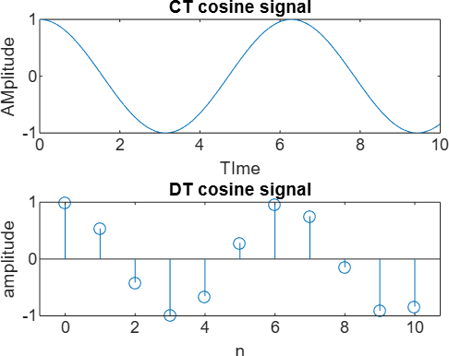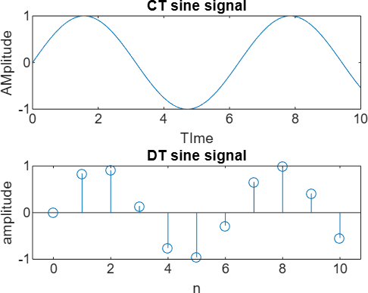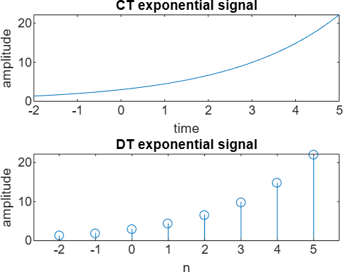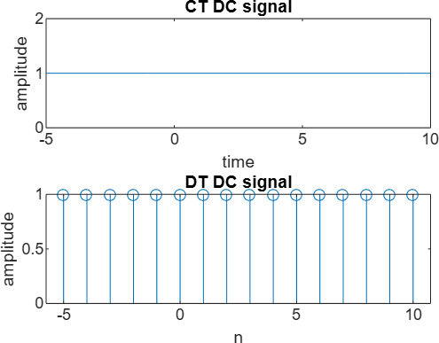

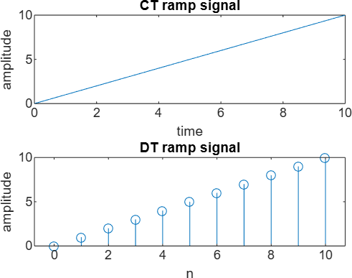 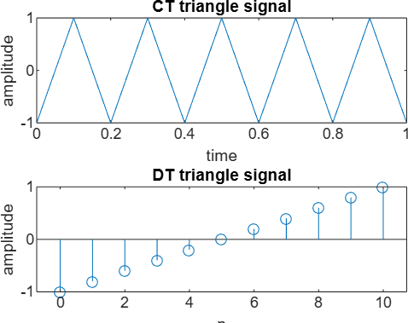

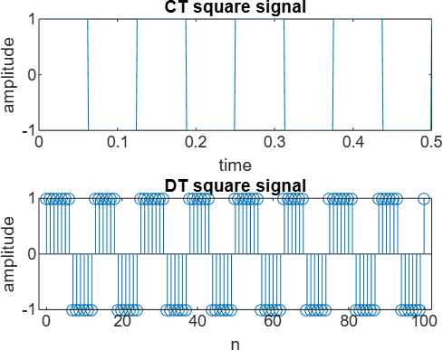

# EXP 2 : sampling theorem and aliasing effects with various sampling frequencies.(5hz,25hz,50hz)

fs1=5; t1=0:1/fs1:1; a1=sin(2*pi*0*t1); a2=sin(2*pi*1*t1); a3=sin(2*pi*10*t1); figure; subplot(3,1,1);

plot(t1,a1);

title("signal with sampling frequency 5Hz"); xlabel("time");

ylabel("amplitude"); subplot(3,1,2);

plot(t1,a2);

xlabel("time"); ylabel("amplitude"); subplot(3,1,3);

plot(t1,a3);

xlabel("time"); ylabel("amplitude"); fs2=25;

t2=0:1/fs2:1; b1=sin(2*pi*0*t2);

b2=sin(2*pi*1*t2); b3=sin(2*pi*10*t2); figure; subplot(3,1,1);

plot(t2,b1);

title("signal with sampling frequency 5Hz"); xlabel("time");

ylabel("amplitude"); subplot(3,1,2);

plot(t2,b2);

xlabel("time"); ylabel("amplitude"); subplot(3,1,3);

plot(t2,b3);

xlabel("time"); ylabel("amplitude"); fs3=50;

t3=0:1/fs3:1; c1=sin(2*pi*0*t3); c2=sin(2*pi*1*t3); c3=sin(2*pi*10*t3); figure; subplot(3,1,1);

plot(t3,c1);

title("signal with sampling frequency 5Hz"); xlabel("time");

ylabel("amplitude"); subplot(3,1,2);

plot(t3,c2);

xlabel("time"); ylabel("amplitude"); subplot(3,1,3);

plot(t3,c3);

xlabel("time"); ylabel("amplitude");

# Output:

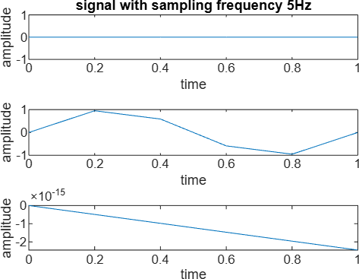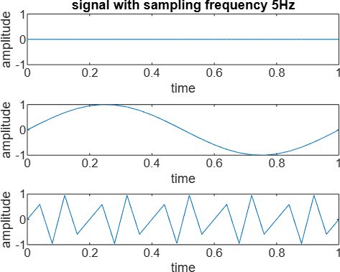

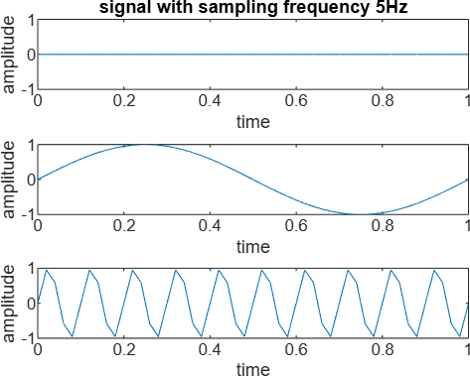

EXP 3: frequency domain analysis of the signal using FFT.

x = [1 1 1 1];

X = fft(x); % FFT of the signal X_mag = abs(X); % Magnitude of FFT X_ang = angle(X); % Phase (angle) of FFT

% Original time-domain signal figure;

stem(x, 'filled');

xlabel('n');

ylabel('x(n)');

title('Original Time-Domain Signal');

% FFT of x figure;

stem(X, 'filled'); xlabel('Frequency Bin'); ylabel('Amplitude'); title('FFT of x');

% Magnitude of FFT figure;

stem(X_mag, 'filled'); xlabel('Frequency Bin (K)'); ylabel('|X(K)|'); title('Magnitude Spectrum of x');

% Phase of FFT figure;

stem(X_ang, 'filled'); xlabel('Frequency Bin (K)'); ylabel('Phase ∠X(K)'); title('Phase Spectrum of x');

% Inverse FFT x_rec = ifft(X)

% Some basic statistics on the magnitude mean_val = mean(X_mag)

min_val = min(X_mag) var_val = var(X_mag) std_val = std(X_mag)

OUtput:

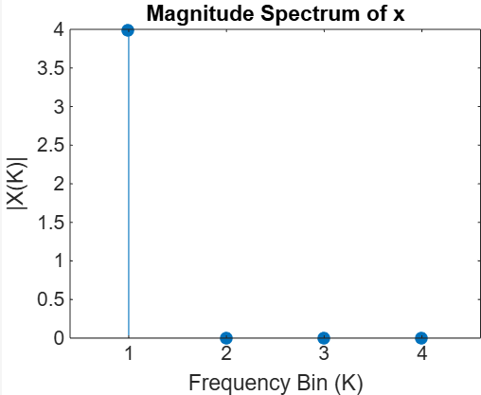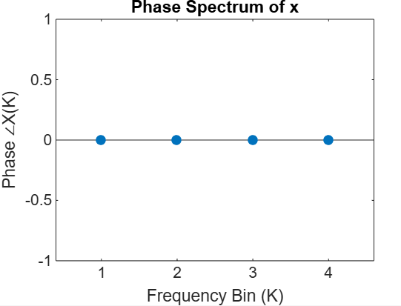

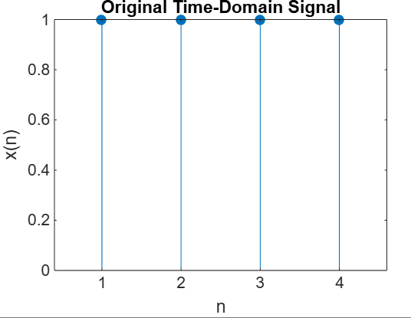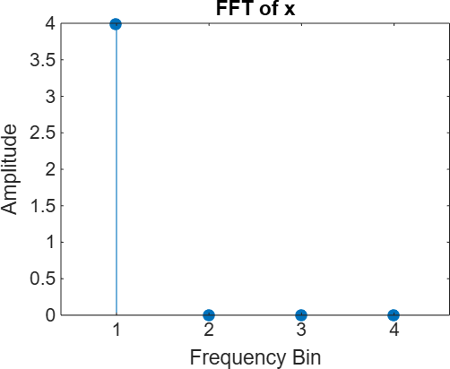

# EXP 4: N point circular convolution.

x = [1 2 3];

h = [1 1 1];

X = fft(x);

H = fft(h); Y = X .* H;

y_circular = ifft(Y);

l1 = length(x); l2 = length(h);

N = l1 + l2 - 1; % Output length for linear convolution x_pad = [x, zeros(1, N - l1)];

h_pad = [h, zeros(1, N - l2)]; X_pad = fft(x_pad);

H_pad = fft(h_pad); Y_pad = X_pad .* H_pad; y_linear = ifft(Y_pad);

figure;

stem(0:length(y_circular)-1, real(y_circular)); title('Circular Convolution using FFT');

xlabel('n');

ylabel('y[n]'); grid on;

figure;

stem(0:length(y_linear)-1, real(y_linear)); title('Linear Convolution using FFT (Zero-Padded)'); xlabel('n');

ylabel('y[n]'); grid on;

# Output:

y =

6 6 6

y =

1.0000 3.0000 6.0000 5.0000 3.0000

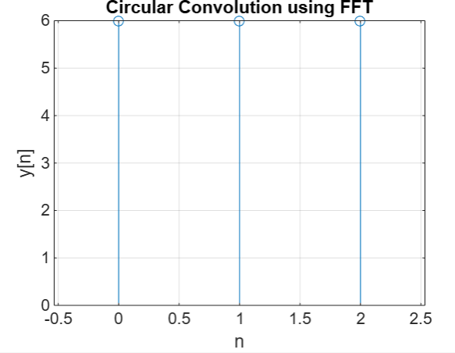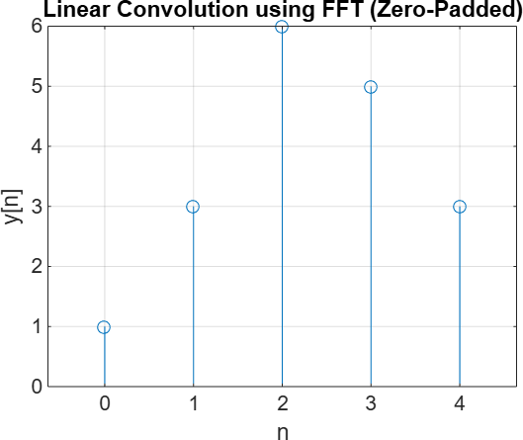

# EXP 5: Design of FIR low pass, band pass, filter using different window method.

wc = 0.5*pi; N = 25;

a = (N-1)/2;

eps = 0.01;

% Low pass filter n = 0:1:N-1;

hd = (sin(wc*(n - a + eps))) ./ (pi*(n - a + eps));

% Rectangular Window

W_rect = boxcar(N);

Wt_rect = transpose(W_rect); h_rect = hd .* Wt_rect; figure;

freqz(h_rect);

title('Frequency Response using Rectangular Window');

% Hamming Window W_ham = hamming(N);

Wt_ham = transpose(W_ham); h_ham = hd .* Wt_ham; figure;

freqz(h_ham);

title('Frequency Response using Hamming Window');

% Hanning Window W_han = hanning(N);

Wt_han = transpose(W_han); h_han = hd .* Wt_han; figure;

freqz(h_han);

title('Frequency Response using Hanning Window');

# Output:

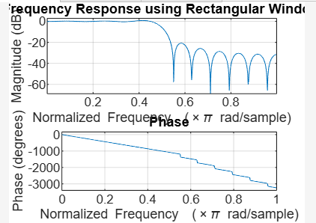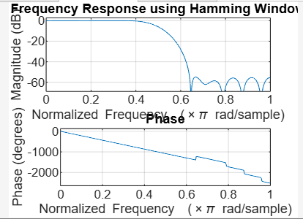

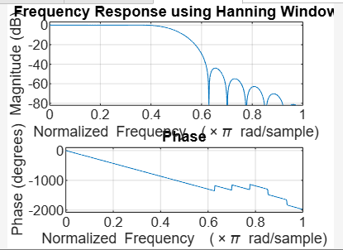

EXP 6: Design of FIR high pass, band stop filter using different window method.

wc = 0.5*pi; % Cut-off frequency N = 25; % Filter length

a = (N - 1) / 2; % Center index

eps = 0.01; % Small epsilon to avoid division by 0

% High-pass filter impulse response n = 0:1:N-1;

hd = (sin(pi*(n - a + eps)) - sin(wc*(n - a + eps))) ./ (pi*(n - a + eps));

% Rectangular Window W_rect = boxcar(N); h_rect = hd .* W_rect'; figure;

freqz(h_rect);

title('High-Pass Frequency Response using Rectangular Window');

% Hamming Window W_ham = hamming(N); h_ham = hd .* W_ham'; figure; freqz(h_ham);

title('High-Pass Frequency Response using Hamming Window');

% Hanning Window W_han = hanning(N); h_han = hd .* W_han'; figure; freqz(h_han);

title('High-Pass Frequency Response using Hanning Window');

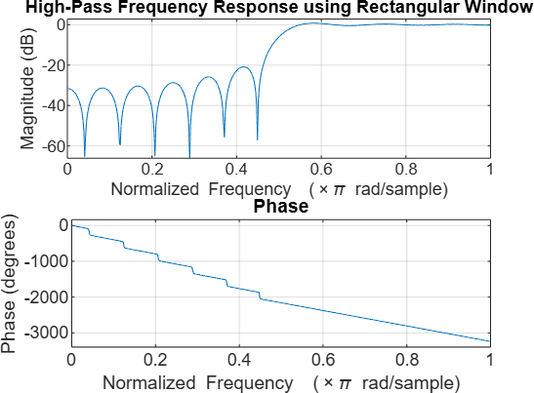 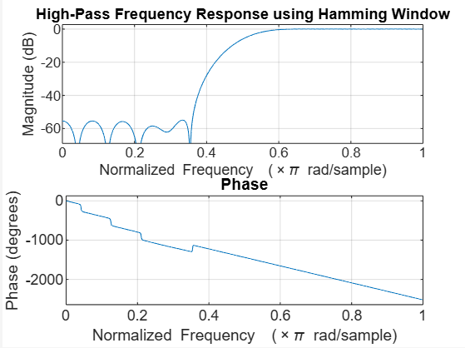

EXP7: Butterworth filter using Bilinear Transformation method for LPF

Ap=0.6; As=0.1;

Wp=0.35*pi; Ws=0.7*pi; T=0.1;

rp=-20*log10(Ap) rs=-20*log10(As) wp=(2/T)*tan(Wp/2) ws=(2/T)*tan(Ws/2)

[N,wc]=buttord(wp, ws, rp, rs, 's') [num_analog, denom_analog]=butter(N, 1, 's') [num1_analog, denom1_analog]=butter(N, wc, 's')

[num2_analog, denom2_analog]=bilinear(num1_analog, denom1_analog, 1/T) w=0:pi/16:pi

H=freqz(num2_analog, denom2_analog, w) H1=abs(H)

plot(w/pi, H1) title("Magnitude plot for LPF") xlabel("frequency (w)") ylabel("response")

grid on

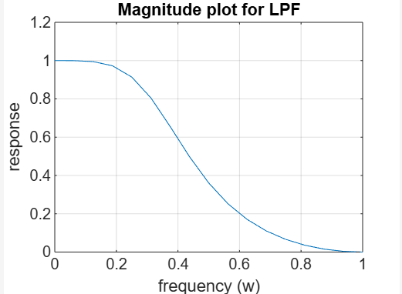

EXP 8 : Butterworth filter using Bilinear Transformation method for HPF.

Ap=0.6; As=0.1;

Wp=0.35*pi; Ws=0.7*pi; T=0.1;

rp=-20*log10(Ap) rs=-20*log10(As) wp=(2/T)*tan(Wp/2) ws=(2/T)*tan(Ws/2)

[N,wc]=buttord(wp, ws, rp, rs, 's') [num_analog, denom_analog]=butter(N, 1, 's')

[num1_analog, denom1_analog]=butter(N, wc, 'high', 's')

[num2_analog, denom2_analog]=bilinear(num1_analog, denom1_analog, 1/T) w=0:pi/16:pi

H=freqz(num2_analog, denom2_analog, w) H1=abs(H)

plot(w/pi, H1) title("Magnitude plot for HPF") xlabel("frequency (w)") ylabel("response")

grid on

